**A PRELIMINARY REPORT ON**

**StudyNotion**

**SUBMITTED TO THE VISHWAKARMA INSTITUTE OF INFORMATION TECHNOLOGY, PUNE**

**IN THE PARTIAL FULFILMENT OF THE REQUIREMENTS**

**FOR THE AWARD OF THE DEGREE**

**OF**

**BACHELOR OF TECHNOLOGY (COMPUTER ENGINEERING)**

##### **SUBMITTED BY**

**STUDENT NAME** **Exam Seat No. :**

Ajay Mehta 22110162

Raj Mandhare 22110389

Utkarsh Adsul 22110096

Sahil Savardekar 22110350

Sagar Patil 22111052

## **DEPARTMENT OF COMPUTER ENGINEERING**

**BRACT’S**

**VISHWAKARMA INSTITUTE OF INFORMATION TECHNOLOGY**

SURVEY NO. 3/4, KONDHWA (BUDRUK), PUNE – 411048, MAHARASHTRA (INDIA).

| **Sr. No.** | | | | **Title of Chapter** | |
| --- | --- | --- | --- | --- | --- |
| **01** | | | | **Introduction** | |
|  | 1.1 | | | Overview | |
|  | 1.2 | | | Motivation | |
|  | 1.3 | | | Problem Definition and Objectives | |
|  | 1.4 | | | Project Scope & Limitations | |
|  | 1.5 | | | Methodologies of Problem solving | |
| **02** | | | | **Literature Survey** | |
| **03** | | | | **System Design** | |
|  | | 3.1 | | System Architecture | |
| **04** | | | | **Project Implementation** | |
|  | | | 4.1 | Overview of Project Modules | |
|  | | | 4.2 | Tools and Technologies Used | |
| **05** | | | | **Results** | |
|  | | | 5.1 | Outcomes | |
|  | | | 5.2 | Screen Shots | |
| **06** | | | | **Conclusions** | |
|  | | 6.1 | | Conclusions | |
|  | | 6.2 | | Future Work | |
|  | | 6.3 | | Applications | |
|  | | | | **References**  ELearning Industry:<https://elearningindustry.com/>  The Online Learning Consortium (OLC):<https://onlinelearningconsortium.org/>  Educause:<https://www.educause.edu/index.html> | |

**1. Introduction**

**1.1 Overview**

StudyNotion is a fully functional ed-tech platform that enables users to create, consume, and rate educational content. The platform is built using the MERN stack, which includes ReactJS, NodeJS, MongoDB, and ExpressJS.

**1.2 Motivation**

StudyNotion aims to provide:

- A seamless and interactive learning experience for students, making education more accessible and engaging.

- A platform for instructors to showcase their expertise and connect with learners across the globe.

**1.3 Problem Definition and Objectives**

The objectives of StudyNotion are to:

- Enhance the learning experience for students.

- Provide a platform for instructors to share knowledge globally.

**1.4 Project Scope & Limitations**

The scope of StudyNotion includes:

- Creating, consuming, and rating educational content.

- Connecting students with instructors worldwide.

Limitations include:

- Time constraints for development.

- Resource limitations for implementing advanced features.

**1.5 Methodologies of Problem Solving**

The methodologies employed in developing StudyNotion include:

- Agile development practices for flexibility and adaptability.

- Continuous feedback loops to refine features and functionalities.

# **2.Literature Survey**

1. **Market Trends in Online Course Platforms**

* Analyse reports from market research firms like Gartner, Forrester, or eLearning Industry to understand the size and growth projections for the eLearning market.
* Compare features and functionalities offered by leading online course platforms like Udemy, Coursera, Skillshare, and others.
* Identify user preferences for online learning experiences through surveys, user reviews, or case studies.

1. **Learner Engagement in Online Courses**

* Explore research on factors that influence learner motivation and engagement in online courses.
* Investigate best practices for designing interactive courses, incorporating multimedia elements, and promoting active learning strategies.
* Analyse the use of gamification techniques (points, badges, leaderboards) to enhance student engagement and motivation.

1. **Monetization Strategies for Online Courses**

* Compare different pricing models for online courses (subscriptions, one-time payments, tiered pricing) and their effectiveness in attracting and retaining students.
* Analyse the benefits and drawbacks of subscription-based models versus traditional one-time payment structures.
* Explore additional revenue streams for online course platforms, such as offering certificates of completion, merchandise, or premium content.

1. **Technical Considerations for Building a Course Selling Platform**

* Investigate best practices for designing user interfaces (UI) and user experiences (UX) for online course platforms, focusing on intuitiveness, ease of navigation, and accessibility.
* Compare and contrast different content delivery methods (streaming vs downloadable content) based on factors like security, user experience, and bandwidth limitations.
* Research secure payment gateway solutions that integrate seamlessly with your platform and comply with industry standards.

**3. System Design**

# **3.1 System Architecture**

The StudyNotion ed-tech platform consists of three main components: the front end, the back end, and the database. The platform follows a client-server architecture, with the front end serving as the client and the back end and database serving as the server.

### **Front-end**

The front end of the platform is built using ReactJS, which is a popular JavaScript library for building user interfaces. ReactJS allows for the creation of dynamic and responsive user interfaces, which are critical for providing an engaging learning experience to the students. The front end communicates with the back end using RESTful API calls.

### **Back-end**

The back end of the platform is built using NodeJS and ExpressJS, which are popular frameworks for building scalable and robust server-side applications. The back end provides APIs for the front end to consume, which include functionalities such as user authentication, course creation, and course consumption. The back end also handles the logic for processing and storing the course content and user data.

### **Database**

The database for the platform is built using MongoDB, which is a NoSQL database that provides a flexible and scalable data storage solution. MongoDB allows for the storage of unstructured and semi-structured data, which is useful for storing course content such as videos, images, and PDFs. The database stores the course content, user data, and other relevant information related to the platform.

### **Architecture Diagram**

Here is a high-level diagram that illustrates the architecture of the StudyNotion ed-tech platform:

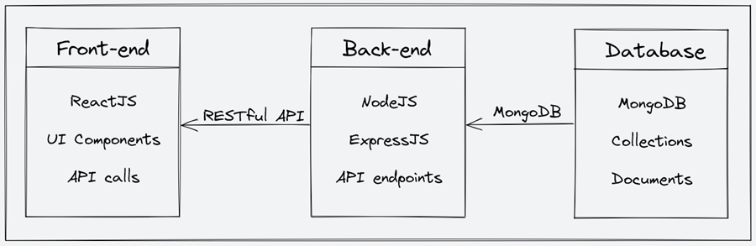

**4. Project Implementation**

**4.1 Overview of Project Modules**

1. System architecture: The high-level overview of the platform's components and diagrams of the architecture.

2. Front-end: The description of the front-end architecture, user interface design, features, and functionalities of the front-end, and frameworks, libraries, and tools used.

3. Back-end: The description of the back-end architecture, features and functionalities of the back-end, frameworks, libraries, tools used, and data models and database schema.

4. API Design: The description of the API design, list of API endpoints, their functionalities, and sample API requests and responses.

5. Deployment: The description of the deployment process, hosting environment and infrastructure, and deployment scripts and configuration.

6. Testing: The description of the testing process, types of testing, test frameworks and tools used.

7. Future Enhancements: The list of potential future enhancements to the platform, explanation of how these enhancements would improve the platform, estimated timeline and priority for implementing these enhancements.

**4.2 Tools and Technologies Used**

### **Frameworks, Libraries, and Tools used:**

The back end of StudyNotion uses a range of frameworks, libraries, and tools to ensure its functionality and performance, including:

1. Node.js: Node.js is used as the primary framework for the back end.

2. MongoDB: MongoDB is used as the primary database, providing a flexible and scalable data storage solution.

3. Express.js: Express.js is used as a web application framework, providing a range of features and tools for building web applications.

4. JWT: JWT (JSON Web Tokens) are used for authentication and authorization, providing a secure and reliable way to manage user credentials.

5. Bcrypt: Bcrypt is used for password hashing, adding an extra layer of security to user data.

6. Mongoose: Mongoose is used as an Object Data Modeling (ODM) library, providing a way to interact with MongoDB using JavaScript.

**5.Results**

**5.1 Outcomes**

**For Learners:**

* Access to a wider range of courses: StudyNotion can provide a platform for instructors to sell their courses, potentially offering a more diverse selection of learning opportunities than any single instructor could provide on their own.
* Improved learning experience: By incorporating research on learner engagement, StudyNotion can strive to create interactive and motivating courses that keep students engaged in the learning process.
* Flexible learning options: The platform can offer on-demand course access, allowing learners to study at their own pace and convenience.

**For Instructors:**

* **Monetization opportunity:** StudyNotion can provide a platform for instructors to sell their courses and generate income.
* **Wider audience reach:** The platform can help instructors reach a broader audience of potential students compared to marketing their courses individually.
* **Simplified course management:** StudyNotion can offer tools for instructors to manage their courses, such as uploading content, tracking student progress, and communicating with learners.

**5.1 Screenshots**

**Home Page :**

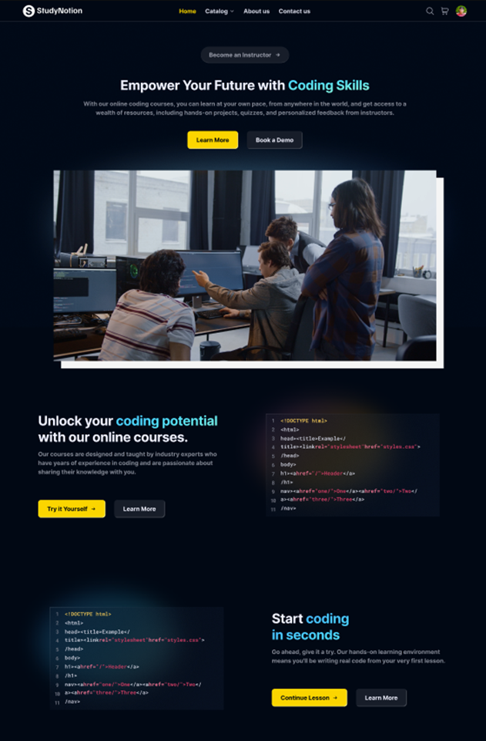

**Login Page:**

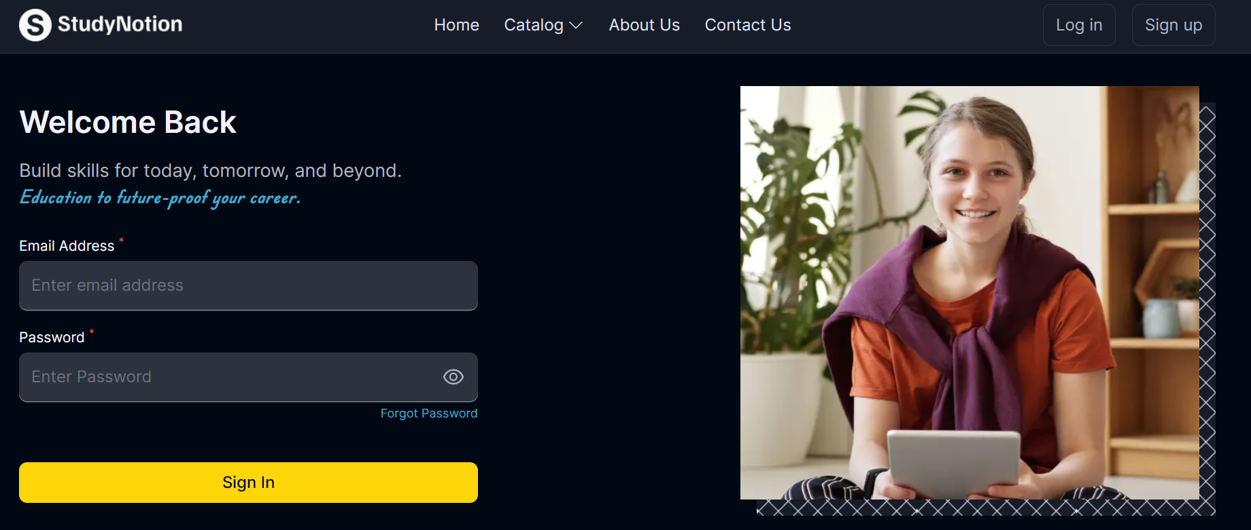

**Sign up Page:**

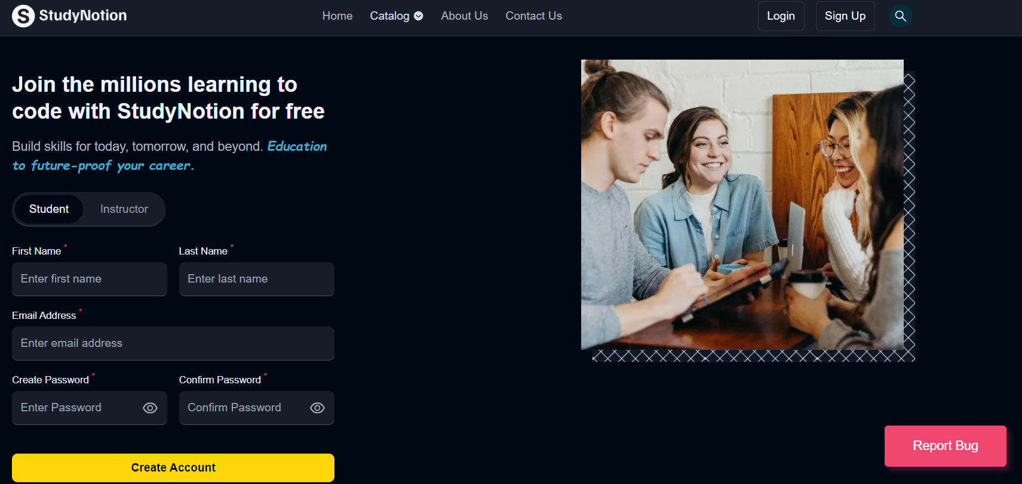

**Contact Us Page :**

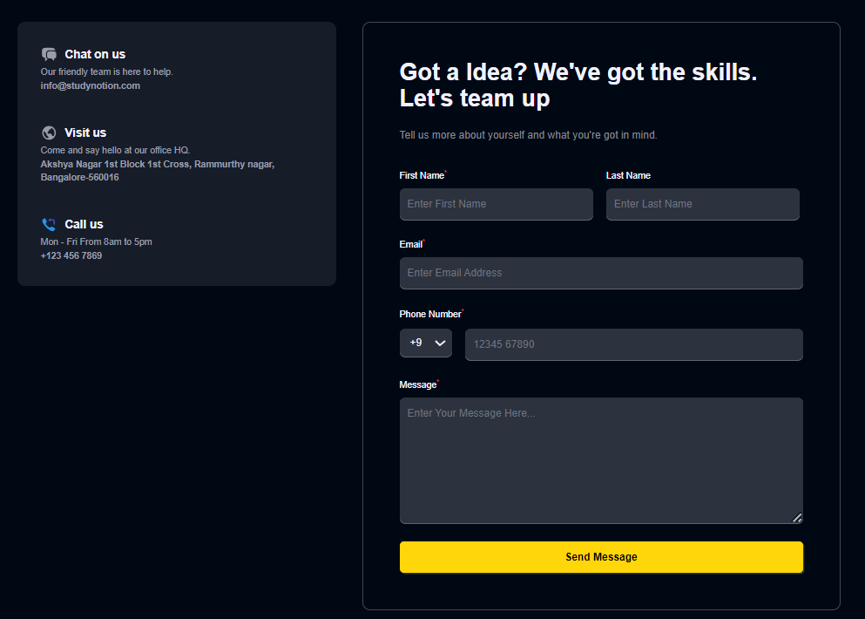

**6.Conclusions**

**6.1 Conclusions**

In conclusion, this document outlines the architecture, features, and functionalities of the StudyNotion ed-tech platform. It highlights the use of MERN stack technologies and REST API design and outlines the deployment process using free hosting services, Vercel for the front-end, Render.com or Railway.app for the backend, and MongoDB Atlas for the database.

**6.2 Future Work**

Throughout the development of the project, various achievements will be made in terms of implementing the desired functionalities and creating a user-friendly interface. However, there will be challenges to be faced during the development process, such as integrating different technologies and debugging errors.

This section discusses potential future improvements to the StudyNotion platform. These enhancements are listed along with an explanation of how they would improve the platform and priority for implementation.

1. Gamification features: Adding gamification features such as badges, points, and leaderboards can increase user engagement and motivation. This would be a medium-priority enhancement.

2. Personalised learning paths: Creating personalised learning paths for each student based on their interests and learning style can increase student satisfaction and success. This would be a high-priority enhancement.

3. Social learning features: Adding social learning features such as group discussions, peer-to-peer feedback, and collaborative projects can increase student engagement and interaction. This would be a medium-priority enhancement.

4. Mobile app: Creating a mobile app for the platform would allow for more convenient access to course content and features, and would increase the platform's reach. This would be a high-priority enhancement.

5. Machine learning-powered recommendations: Using machine learning algorithms to provide personalised course recommendations can improve student engagement and satisfaction. This would be a medium to high-priority enhancement.

6. Virtual reality/augmented reality integration: Adding virtual reality or augmented reality components to certain courses can enhance the learning experience and make it more immersive. This would be a low to medium-priority enhancement.

**6.3 Applications**

Overall, these enhancements would significantly improve the StudyNotion platform and its offerings to students, instructors, and administrators. The implementation timeline and priority would depend on various factors such as the resources available and the specific needs and goals of the platform.